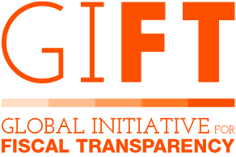
OpenSpending

Introduction for government partners

What is OpenSpending?
OpenSpending tools
OpenSpending Packager
OpenSpending Admin
OpenSpending Viewer
OpenSpending DataMine
OpenSpending Data Package Pipeline
OpenSpending API
The Open Fiscal Data Package
Why did we develop the Open Fiscal Data Package?
Uploading fiscal data to OpenSpending
How is Open Knowledge International engaging with government partners?
Part 1: Selecting and preparing data
Part 2: Uploading and analyzing data
Part 3: Acquainting government partners with OpenSpending ecosystem.
Project scope overview
Frequently Asked Questions around OpenSpending
Useful links
Contacts at OpenSpending and the government partner

What is OpenSpending?
With OpenSpending, Open Knowledge International created the opportunity for governments, civil society organizations and communities to publish and visualize their revenue, budgets, spending and procurements data in an open source platform.
By reducing the barriers to accessing and interpreting fiscal open data, OpenSpending enables analysis, dissemination and debates for more efficient budgets and puglic spending.
OpenSpending is designed, developed and maintained by Open Knowledge International and, as an open source and a community-driven project, also reflects the valuable contributions of an active, passionate and committed community. The project has been running since 2009, starting as “Where Does My Money Go.”
OpenSpending consists of a core platform with a large, centralised database that allows for deep analysis across a range of datasets. At the same time, OpenSpending offers tools that enable to establish an ecosystem around fiscal data, which is tailored to the specific aspects and local contexts the data is embedded in.

OpenSpending tools

OpenSpending Packager
Via OpenSpending Packager fiscal data can be uploaded from alternate sources (csv, Excel, Google Sheets and Fiscal Data Package). Data and metadata can be uploaded in 4 simple steps.
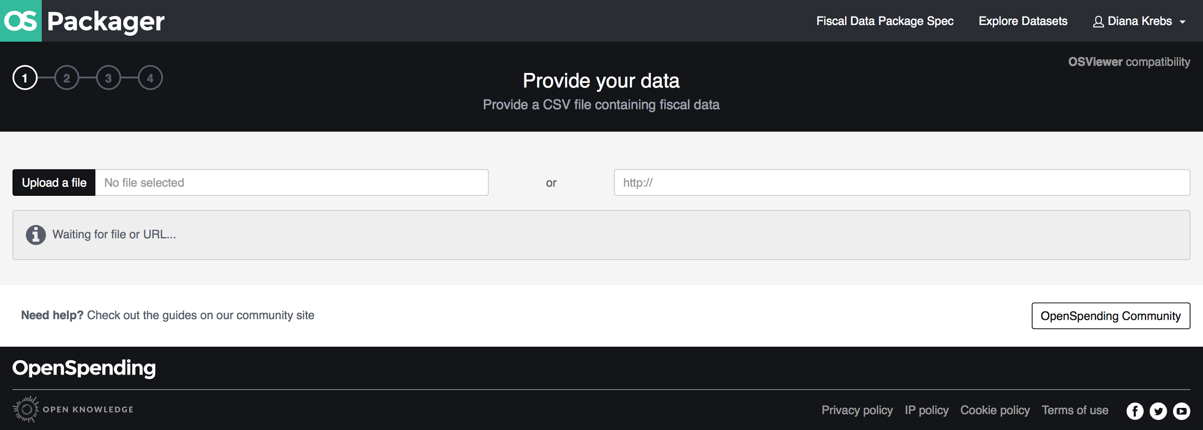

OpenSpending Admin

OpenSpending Admin offers the possibility to administer a user account and the associated data packages that have been loaded to the platform.
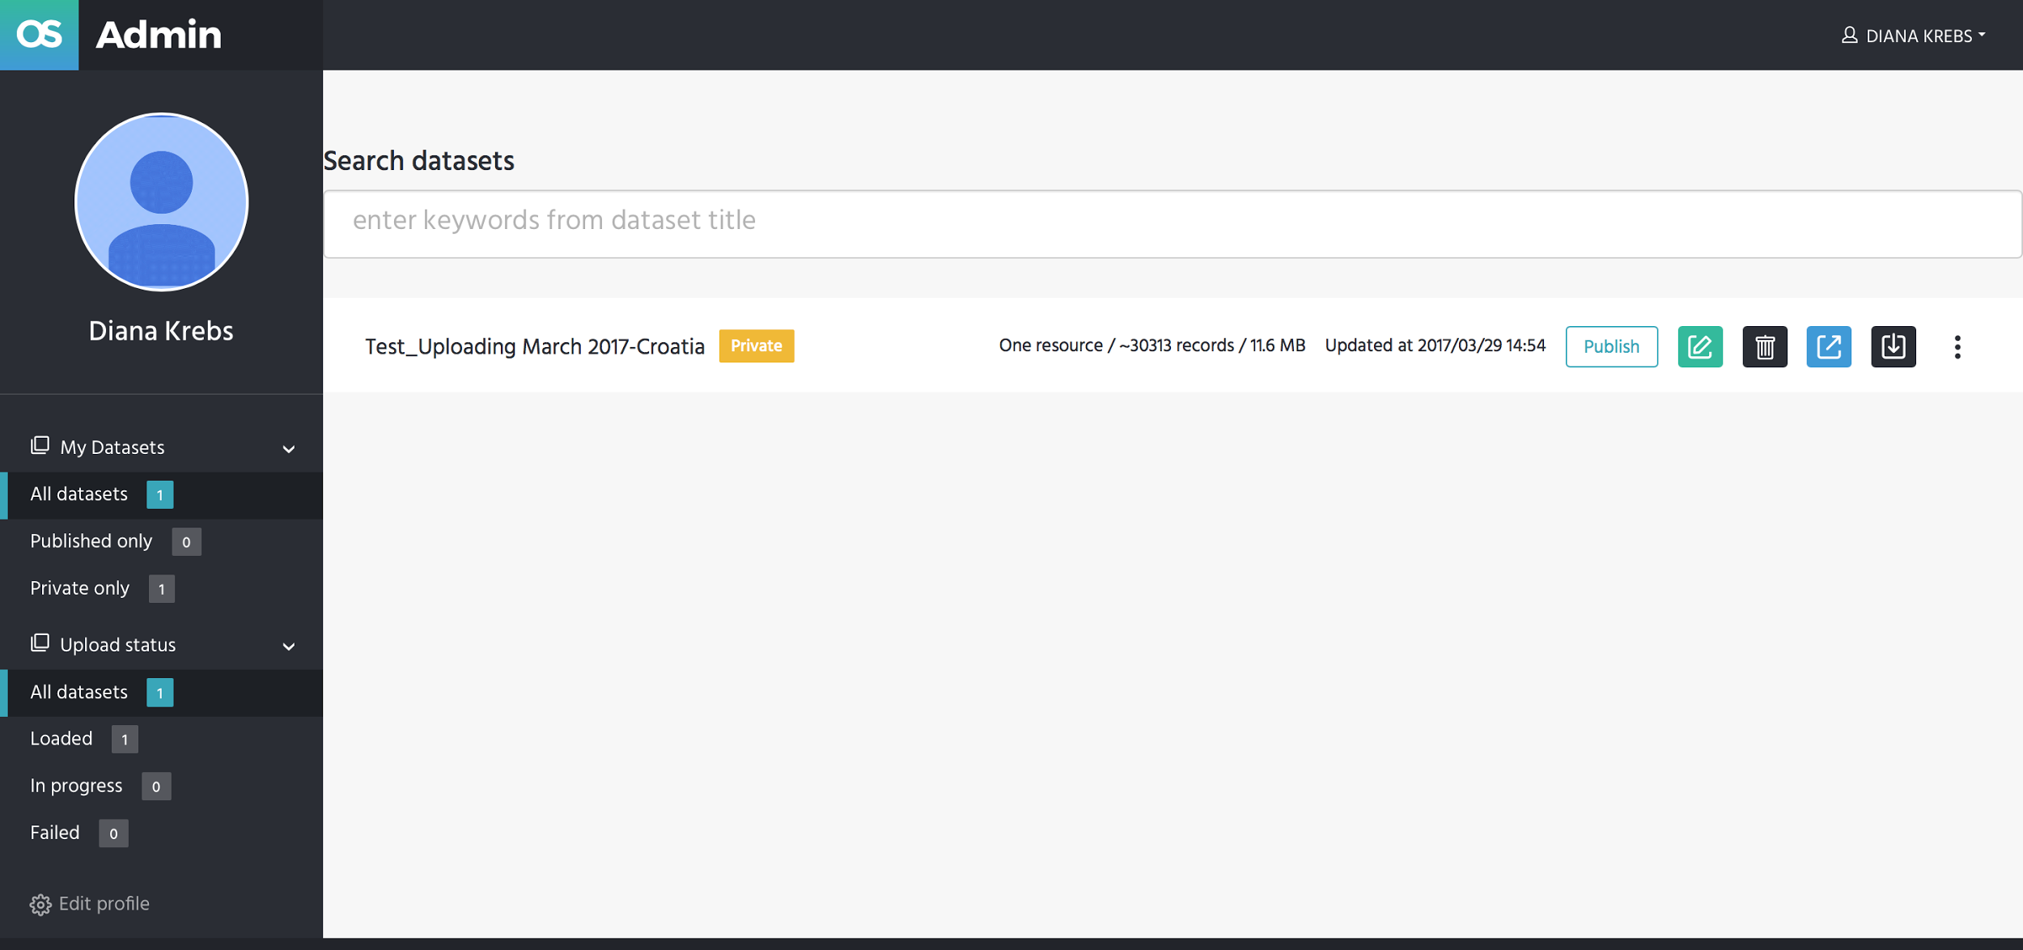

OpenSpending Viewer
The OpenSpending Viewer is a Javascript app that provides views over data uploaded to OpenSpending. It offers 8 different visualisations and a pivot table for analyzing the data.
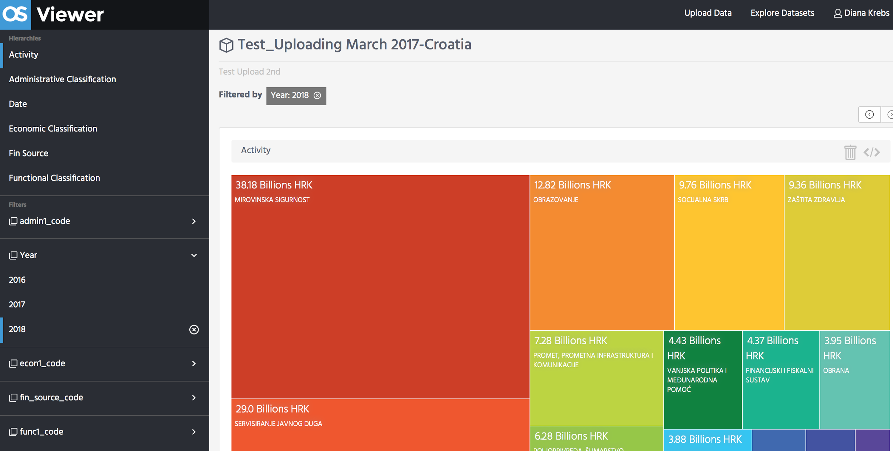
OpenSpending DataMine
The OpenSpending DataMine is an experimental feature for investigative analysis of data with direct access to read any part of the database. This feature can be used (and it is encouraged!), but currently it is not subject to further customisation.

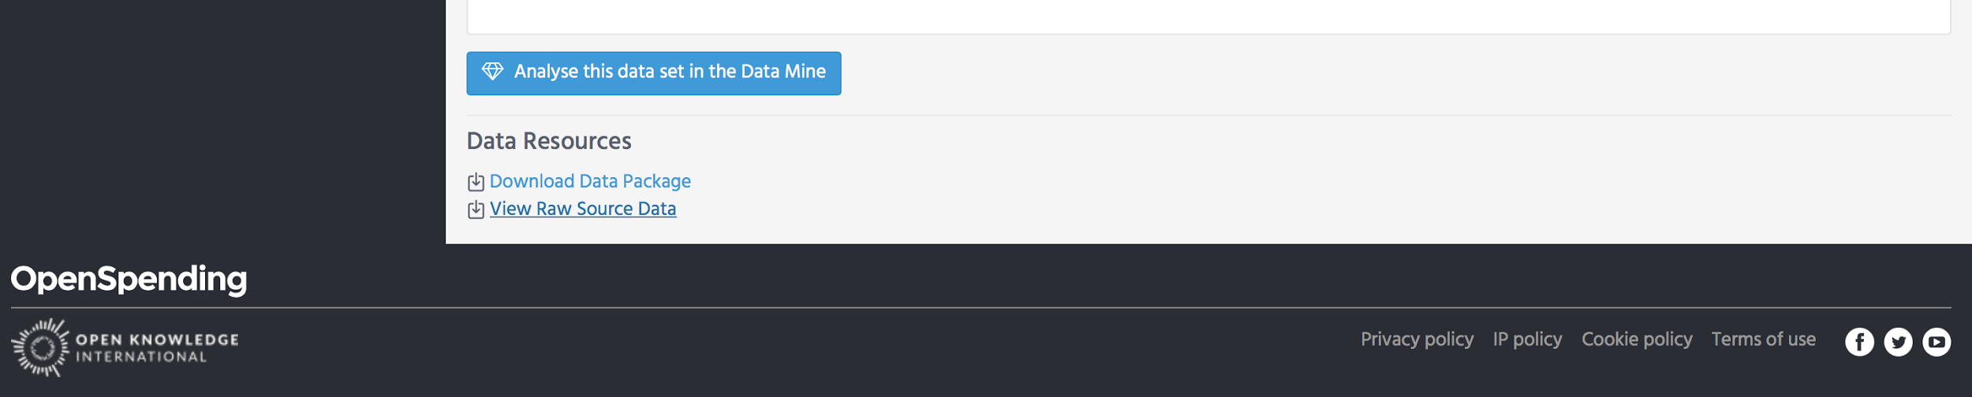

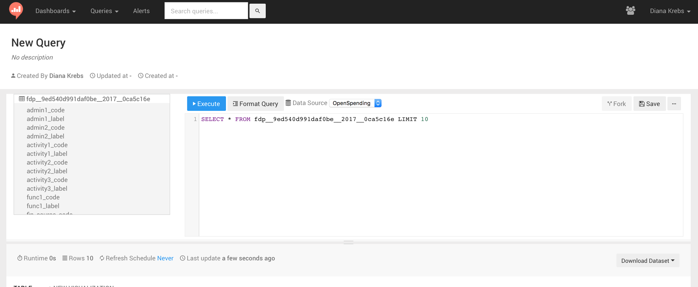

OpenSpending Data Package Pipeline
The OpenSpending Data Package Pipeline component allows the definition (by a developer) of custom pipelines that read data from one or many external sources, and ingest it into OpenSpending as a valid Fiscal Data Package.
The OpenSpending Pipelines component provides a feature for OpenSpending to “subscribe to changes” in the source data for a pipeline, and, at regular intervals (for example: weekly), update OpenSpending if the source file(s) changed.
Read more here

OpenSpending API
OpenSpending has a rich API which allows OLAP-style querying of fiscal data, and search functionality to find packages. API documentation is available here.

The Open Fiscal Data Package

Why did we develop the Open Fiscal Data Package?

Ever since OKI has started OpenSpending, the recurrent challenges for those who published data were:
1. Fiscal data in most cases comes in unstructured and inconsistent data formats.
2. To be fully understood, fiscal data has to be embedded into its local context
During the past two years, in collaboration with the Global Initiative of Fiscal Transparency (GIFT), the BOOST World Bank initiative and a dedicated open data community, the OpenSpending team worked on a new specification for publishing fiscal data that would take these aspects into consideration and serve as a standard: Fiscal Data Package.
The Open Fiscal Data Package is a simple, open, technical specification for publishing government budget and spending data. It aims to be easy to use both for those publishing data (e.g. governments) and for those wanting to use the data (such as researchers and journalists).
The Open Fiscal Data Package serves two main purposes:
- Standardizing the structure and the content of fiscal data so that tools and services can be built over it for visualization, analysis or comparison;
- Driving data quality by providing a solid framework of publication.
So the Open Fiscal Data Package specifies the form for fiscal data and offers a standardized framework for the content.
The Open Fiscal Data Package takes into effect when

1. Mapping the CSV into standard concepts (step 2)
2. Providing metadata to the package (step 3)
3. When stored in our datastore, it’s conforming to the standard.
4. OS Viewer works with the standard to understand the structure and meaning of each concept in the raw data.
To date, the Fiscal Open Data Package has been used by the Federal Government of Mexico, which publishes the 2017 Federal Budget using the tool, and uploaded 10 years of budget to the open source platform OpenSpending.
Currently, other governments such as Croatia, Paraguay, Guatemala and Uruguay, are piloting the tool and planning to publish soon their budgets with the tool. Their data sets are openly accessible via OpenSpending:
Croatia:
https://next.openspending.org/viewer/6018ab87076187018fc29c94a68a3cd2:croatia-budget-plan
Paraguay
https://next.openspending.org/viewer/boost:boost-paraguay-central-and-decentralized-entities
Guatemala:
https://next.openspending.org/viewer/6018ab87076187018fc29c94a68a3cd2:boost-guatemala-central
Uruguay:
https://next.openspending.org/viewer/6018ab87076187018fc29c94a68a3cd2:boost-uruguay

Uploading fiscal data to OpenSpending

How is Open Knowledge International engaging with government partners?

As part of the GIFT collaboration, Open Knowledge International has been working with a number of governmental and administrative partners to increase fiscal transparency by uploading their budget data to OpenSpending and implementing the Open Fiscal Data Package.
How do we engage with government partners during the course of the GIFT collaboration:

Part 1: Selecting and preparing data
To find the most suitable data sets possible is one of the team’s first task when making the introductory calls with the government partners.
From our vast experience with open data, preparing the dataset for uploading it to OpenSpending takes the largest amount of time.
Before the first upload and analysis, we will work closely with the government partner to identify data sets for upload and to understand the data, including the meaning of each column (classification, direction, etc.). The teams will work together to ensure that the data package is meeting a minimum set of quality requirements.
More information on quality requirements of the data you find here: http://docs.openspending.org/en/latest/contributors/prepare/#prepare-data-for-openspending

Part 2: Uploading and analyzing data
When your fiscal data has been prepared for publication, we will proceed to uploading together with the government partners the data, using OS Packager and OS Viewer.
If requested we will give you an introduction to OS DataMine and OS API.
OS Packager provides a simple user interface, to load data into OpenSpending, while OS Viewer allows to explore the data and select from five visualization types (such as Tree Map, Pie Chart or Line Chart), as well as using a table or a pivot table. Visualizing the data enables to put complex figures into context in order to better understand and analyze fiscal data.
Full steps on uploading and analyzing data are available at http://docs.openspending.org/en/latest/contributors/load/ and http://docs.openspending.org/en/latest/users/interact/.

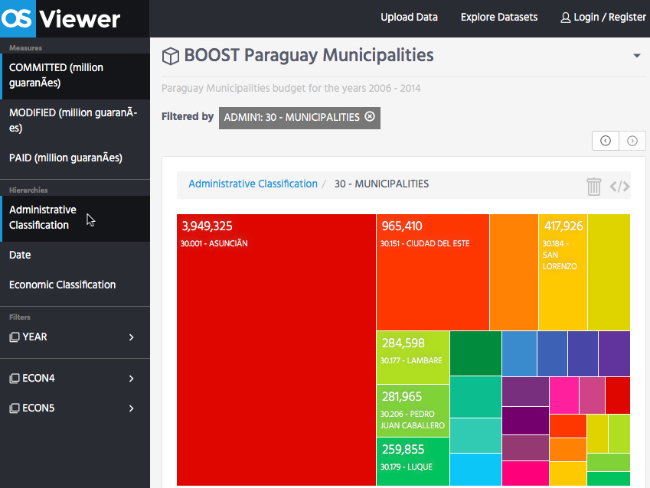
Example: preview of BOOST Paraguay Municipality budget data

As a result of our collaboration, we aim to have government partners continue using the Fiscal Data Package and OpenSpending tools as the self-service tools they have been developed, even when our government project is completed. This ensures project sustainability and potentially promoting the tools to other parties. All steps in working with OpenSpending tools to publish data packages are comprehensively documented on http://docs.openspending.org/en/.

Part 3: Acquainting government partners with OpenSpending ecosystem.
Open Knowledge International will acquaint government partners with the OpenSpending ecosystem. We recommend two session calls. One is to explain the mapping of a dataset while at the same time we upload the respective dataset. The second session explains how the pipelines are working and how government partners make better use of it.

Project scope overview
This section describes the proposed four work phases with the government partner and what these include. These are subject to discussion with the government partner and are to be defined in the first few introductory calls, within a project plan.
Tasks (not in strict order) | Output | Lead
Contextual inquiry (Open Government Partnership involvement, Open Data commitment on a federal and local level, fiscal transparency efforts in the country, open data community and CSOs around) | Background information form added to the project plan | OS
Introductory call with government partner:  - introduction of the teams  - getting to know the needs and demands as well as the already existing data infrastructure and data acquisition of the government partners | Call minutes with summary of agreed next steps | GIFT, WB, OS
Assisting government partner in selecting suitable data sets. | Complete list of data sets selected made available to OS team and link to source added to project plan | OS
Drafting a timeline with as to data wrangling and upload to OpenSpending | Clear list of deliverables and timelines | government partner & OS, with GIFT and WB in information loop
Dataset documentation (description of dataset) provided by government project partner | Data assessment by OS team | government partner & OS
Data wrangling (data cleaning, data scraping etc) and upload dataset to OpenSpending | Clean data set ready for upload | government partner & OS
Provide 1-2 training sessions on how to upload a dataset to OpenSpending & how to map the data;
Creating an automated pipeline to be used for data updates (frequency to be determined) | government partner acknowledges familiarity with using the automated pipeline | OS
Assisting government partner in uploading dataset, mapping the data and using OS spending tools | Data package uploaded to OpenSpending | OS
Translate OS Viewer strings and make available in (language) | OS Viewer available in language | OS
Testing and bug fixing | Number of bugs opened and closes on GitHub | OS
Monitoring government project implementation activities | Being on stand-by for government partner’s launch activities | OS, with GIFT and WB in information loop
Technical wrap-up | Processing of open tasks/ bugs, in close cooperation with government tech team | government partner &  OS

Frequently Asked Questions around OpenSpending

Q: Do I have to install OpenSpending on my own servers?
A: You don’t need to install OpenSpending in order to use it, or even for an embedded version of the OS Viewer.

Q: What browsers can I work with for OpenSpending?
A: It is possible to work with OS in Google Chrome, Safari and IE.

Q: I have an issue with my data, how can I solve it?
A: Raise the issue tracker on https://github.com/openspending/openspending/issues, reach out to the project team, or as otherwise agreed.

Q: What format should my data be in?
A: For now, OpenSpending accepts data in a single file format, the Comma-Separated Values (CSV) file (or a URL to a CSV file). We are working to implement data upload in Excel, and URLs for files other than CSV.

Q: I can’t find the dataset I published. Did I lose my work?
A: You might want to check OS Admin, which enables you to publish or unpublish data.

Q: Can I customise OpenSpending?
A: You can submit a feature request on the issue tracker.

Q: Is OpenSpending available in my own language?
A: The scope of the government includes the translation of the OS Viewer so that OpenSpending is available in the respective language.

Q: OpenSpending is loading data too slowly, what can I do?
A: Submit a bug on the issue tracker.

Q: Can I make changes after I have uploaded the data?
A: Data can be re-uploaded to make changes.

Q: Where can I connect with the larger OpenSpending community?
A: OpenSpending has a vibrant community of budget activists, developers, data wranglers and many more. You can connect with the community on the OpenSpending discussion forum, on Gitter.im in the OpenSpending chat room, on Twitter and Facebook.

Useful links
For more information about OpenSpending, please refer to our various resources:

OpenSpending Next - http://next.openspending.org
OpenSpending on GitHub - https://github.com/openspending
OpenSpending Documentation - http://docs.openspending.org/
Fiscal Data Package - http://fiscal.dataprotocols.org
Dedicated forum for discussions - https://discuss.okfn.org/c/openspending
OpenSpending on Facebook - https://www.facebook.com/OpenSpending/
OpenSpending on Twitter - https://twitter.com/openspending
Community blog - community.openspending.org (currently being revised)

Contacts at OpenSpending and the government partner
Your team at OpenSpending:
Diana Krebs - Project manager, diana.krebs@okfn.org, questions related to project scope, overseeing deliverables, deadlines etc.
Adam Kariv - OpenSpending Tech Lead, adam.kariv@okfn.org, is responsible for all technical issues

Usual communication channels:
Email - to arrange calls, to share minutes call.
GitHub issue tracker - It is recommended that for bugs and issues you encounter with the OS Viewer and other tools, you report these directly on the OpenSpending issue tracker.
Video calls - weekly calls on Skype (or as arranged).

As of April, the project team is in regular contact by email and video meetings, with the government partner. This regular communication will continue up until project completion end of March 2018.

